22nd July 2015

**YOKOHAMA Begins 2nd Stage of Ecological Preservation Project in China’s Yunnan Province**

Tokyo ‒ The Yokohama Rubber Co., Ltd., announced today that Yokohama Rubber (China) Co., Ltd., the holding company for its operations in China, has entered the 2nd stage of its ecological preservation project in the Heyuan Village inside the Laojun Mountain Nature Reserve near Lijiang City in China’s Yunnan Province. The project’s 1st stage ran from 2011 through 2014, with activities focused on the Heyuan Village inside the Laojun Mountain Nature Reserve. Second stage activities were launched on June 25, 2015, in the Liguang Village, with participation from employees of Yokohama Rubber (China).

The ecological preservation project in the Laojun Mountain area is a unique endeavour to preserve the local ecology by transforming rural villages where the only previous means of earning a living was to cut down trees and engage in other activities that led to deforestation into villages with economies based on agriculture and livestock. The project was first advocated in 2010 by the Beijing SanSheng Environment and Development Research Institute, a Chinese environment NGO, and YOKOHAMA has been an active supporter of the project since activities started in 2011. In Liguang Village, the project will follow the same steps taken at Heyuan Village.

In the project’s first year in Heyuan, a “Village Bank” was established to provide the financing needed to transform the village economy from deforestation to agriculture and livestock rearing. Also, “the Laojun Mountain Heyuan Natural Ecosystem Industry Cooperative” was set up to promote research on agriculture and livestock production. In the second year, 2012, the project began providing financial support to cover the cost of sending children to school for families whose income had been temporarily reduced by the transition to a more environmentally friendly agriculture-based village economy. Third-year activities focused on the donation of equipment needed for processing agricultural and livestock products, such as beekeeping equipment. Last year, the project's fourth year, saw the establishment of the Sales Platform of Ecological Agricultural & Forestry Products to help villagers reap an economic profit from the fruits of their new efforts. As a result of the program’s activities over the past four years, as of March 2015 63% of village households have started up new ventures with financing from the Village Bank, and 3,055ha of forest land have been protected by a deforestation ban established by the village residents on their own accord. YOKOHAMA has been a staunch supporter of all these activities, providing materials as well as financial aid.

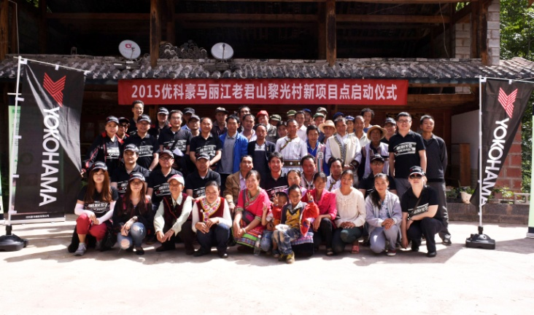

***Photo taken to commemorate start of project activities in Liguang Village***